23. Joined Report - 21 June 2021

1] Tabular Report

2] Summary Report

3] Matrix Report

4] Joined Report

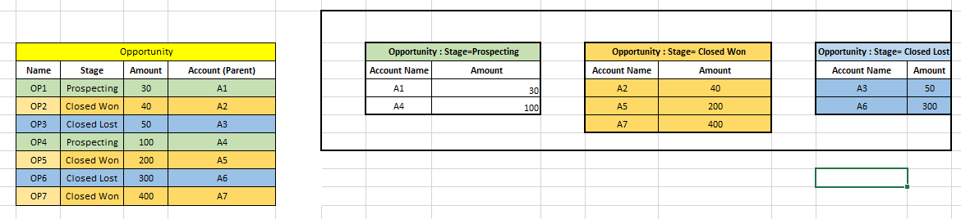

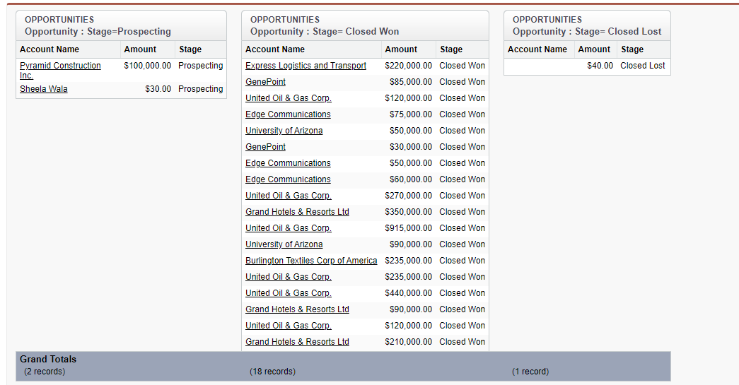

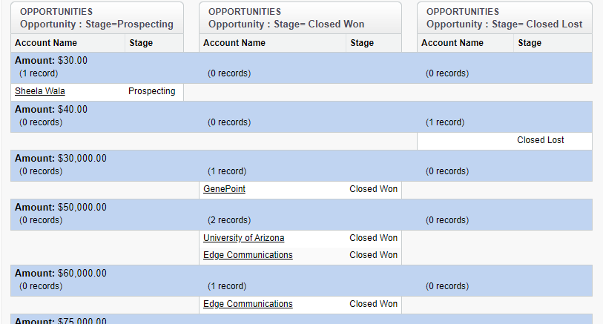

Contact Joined Report

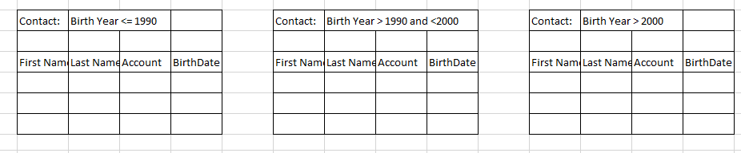

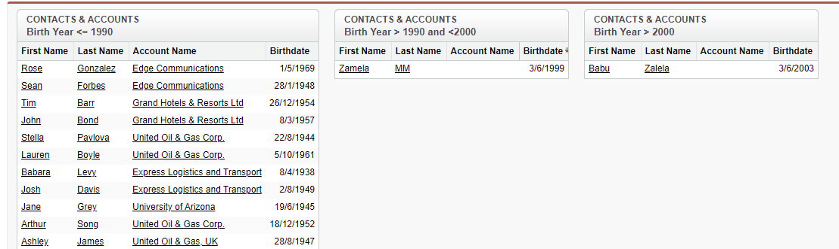

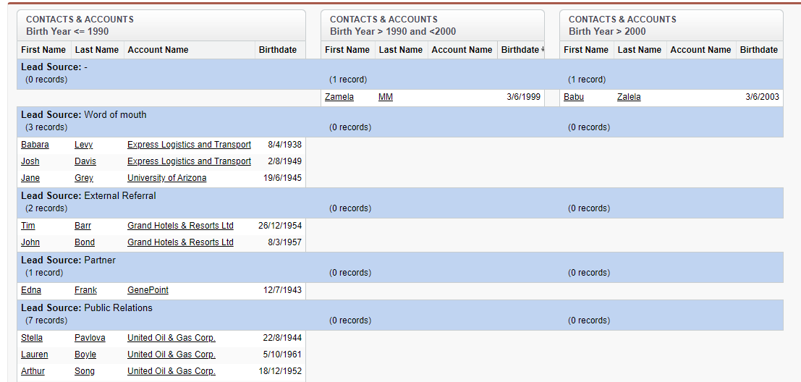

Assignment : Add Formula